8.3 Bond energy
Name: ____________________ Class: ____________________ Due date: 12.22
1. Hydrogen burns exothermically in oxygen.
The equation for the reaction is:
2H₂ + O₂ → 2H₂O
The table shows the bond energies involved.
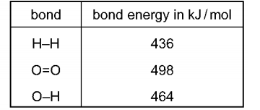
What is the energy given out during the reaction? （ ）
A −3226 kJ/mol B −884 kJ/mol C −486 kJ/mol D −442 kJ/mol

2. The equation for the reaction between hydrogen and chlorine is shown.
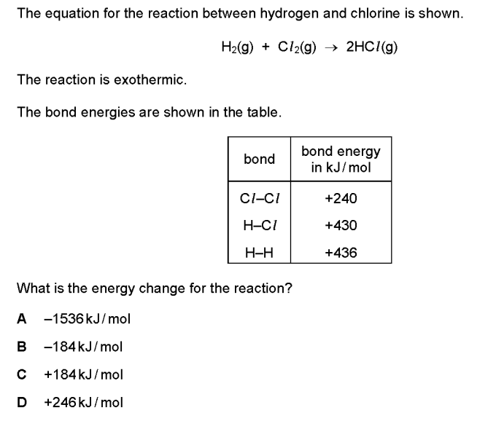
The reaction is exothermic.
The bond energies are shown in the table.
What is the energy change for the reaction? （ ）
A −1536 kJ/mol B −184 kJ/mol C +184 kJ/mol D +246 kJ/mol

3. The energy level diagram for the combustion of methane is shown.
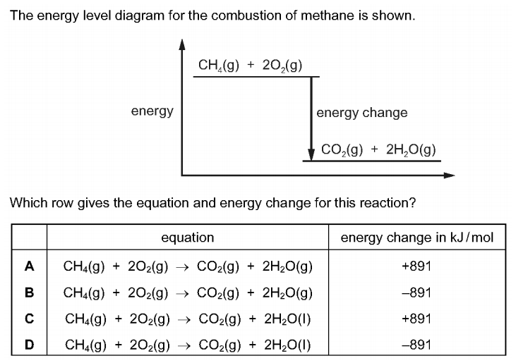
Which row gives the equation and energy change for this reaction? （ ）
4. Chlorine reacts with ethane to produce chloroethane and hydrogen chloride.
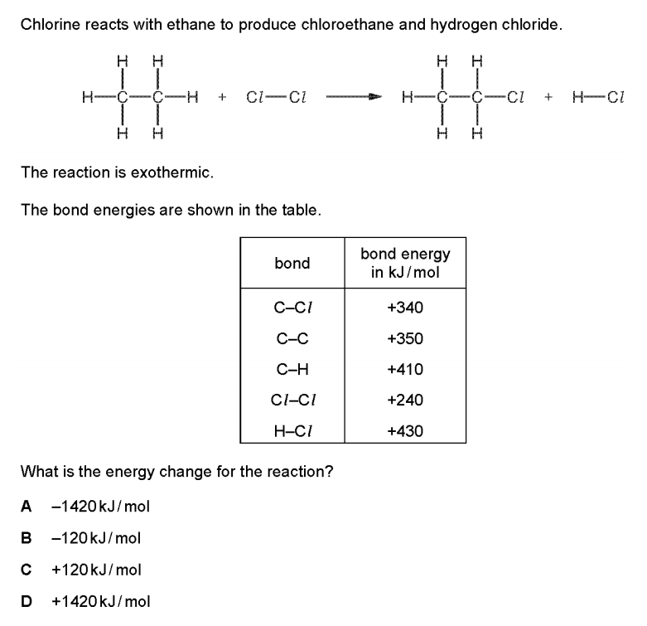
The reaction is exothermic
The bond energies are shown in the table
What is the energy change for the reaction? （ ）
A −1420 kJ/mol B −120 kJ/mol C +120 kJ/mol D +1420 kJ/mol

5. The equation for the combustion of methane is shown.
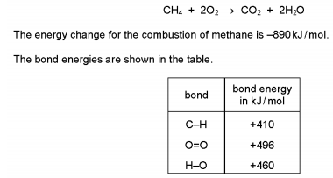
What is the bond energy of the C=O bond? （ ）
A +49 kJ/mol B +841 kJ/mol C +1301 kJ/mol D +1335 kJ/mol

6. Hydrogen and chlorine react to form hydrogen chloride.
The reaction is exothermic.
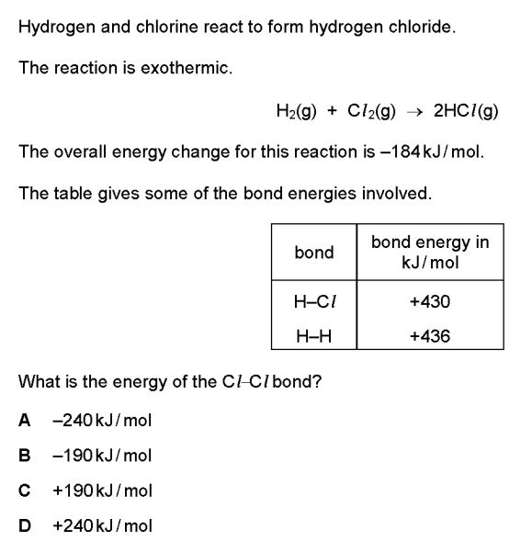
The overall energy change for this reaction is -184kJ/mol
The table gives some of the bond energies involved.
What is the energy of the Cl–Cl bond? （ ）
A −240 kJ/mol B −190 kJ/mol C +190 kJ/mol D +240 kJ/mol
7. Ethene reacts with hydrogen. The equation is shown.
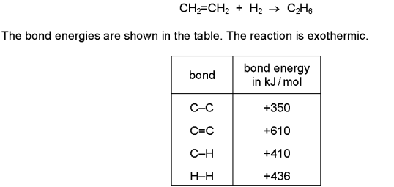
What is the energy change for the reaction? （ ）
A −560 kJ/mol B −124 kJ/mol C +486 kJ/mol D +5496 kJ/mol

8. The chemical equation for the complete combustion of methanol, C₂H₅OH, is shown.
2CH₃OH + 3O₂ → 2CO₂ + 4H₂O
The equation can be represented as shown.
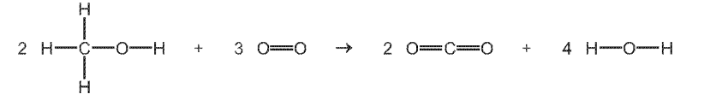
Use the bond energies in the table to determine the energy change, ΔH, for the complete combustion of one mole of methanol.
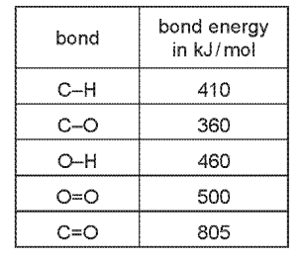
• energy needed to break bonds
............................ kJ
• energy released when bonds are formed

............................ kJ
• energy change, ΔH, for the complete combustion of one mole of methanol

.........................kJ/mol

